|  |  |  |  |  |  |
| --- | --- | --- | --- | --- | --- |
| Date | 14-Dec-22 | | | Tester Name | Select Name |
| Environment | Penfax - Test | | | Login used | Janette P |
| Operating System | Select OS | Version: 21H2 | Update: | | |
| Software Used | Select Software | Version: 107.0.1418.56 | Update: | | |
| Select Software | Version: | Update: | | |
| Release version | 22.4.1 | | | | |
| Title | E27.27 | | | | |
| Test Type | Regression | | | | |
| Test Scenario | Invoice Letter Template | | | | |
|  | Am using PENFAX Test 2 Region | | | | |
| Expected Results | The Invoice/Letter will show the Breakage and Administrative Fee for any ER Negative Breakage and the Late Fee associated with any late remittance (whether there is billable breakage or not) | | | | |
| Pass/Fail | Fail | | | JIRA# | N/A |

The letter portion is correct, however, the “extra cost to the Employer is incorrect, it should have an additional $45.00 for the Administration (Late) Fee for the current breakage occurrence.

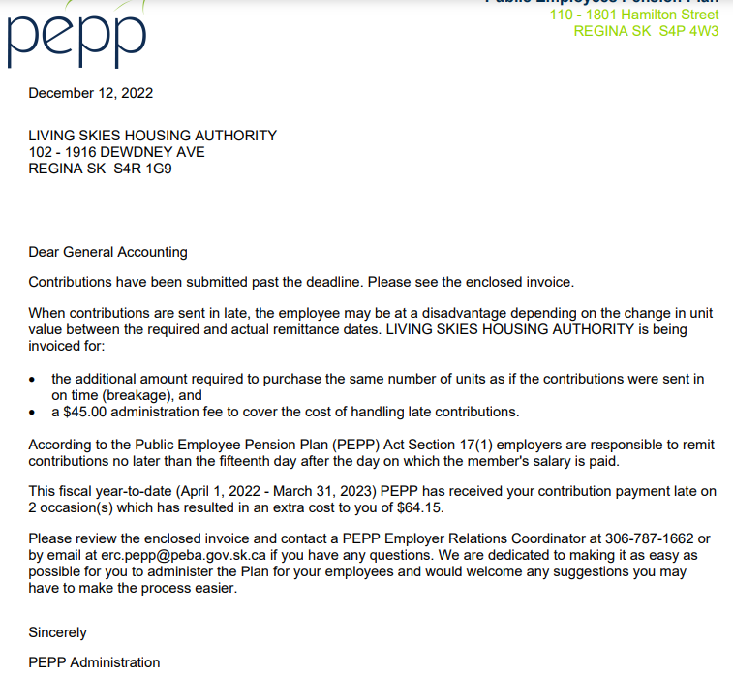

There is no Administration Fee included in the invoice:

